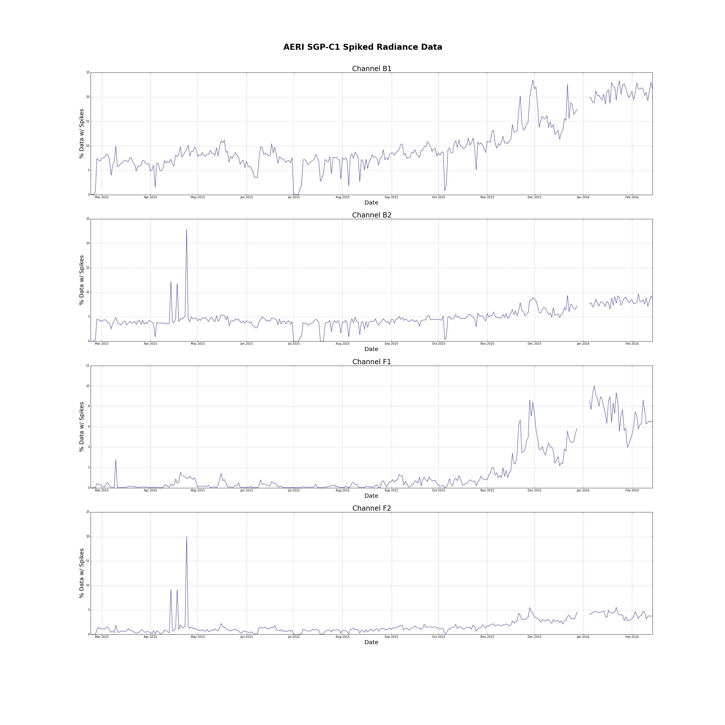

|  |  |  |  |  |  |
| --- | --- | --- | --- | --- | --- |
| Percentage of Scenes w/ Spikes | | | | | |
| Scene | B1 | B2 | F1 | F2 | All Channels |
| H | 10.17559% | 4.97102% | 1.69012% | 1.70525% | 4.63550% |
| A | 10.18610% | 4.90820% | 1.65449% | 1.70382% | 4.61315% |
| S | 10.13585% | 4.81124% | 1.69479% | 1.77246% | 4.60358% |
| T | 10.39034% | 4.95892% | 1.63115% | 1.75342% | 4.68346% |
| U | 10.29950% | 4.98843% | 1.68264% | 1.67934% | 4.66248% |
| V | 10.13767% | 4.85426% | 1.66173% | 1.73777% | 4.59786% |
| W | 10.31518% | 4.98396% | 1.67675% | 1.72967% | 4.67639% |
| X | 10.30336% | 4.93934% | 1.67621% | 1.78338% | 4.67557% |
| Y | 10.28105% | 4.95589% | 1.67424% | 1.75498% | 4.66654% |
| Z | 10.14205% | 4.94923% | 1.73160% | 1.69520% | 4.62952% |
| All | 10.23658% | 4.93200% | 1.69474% | 1.73152% | 4.64437% |